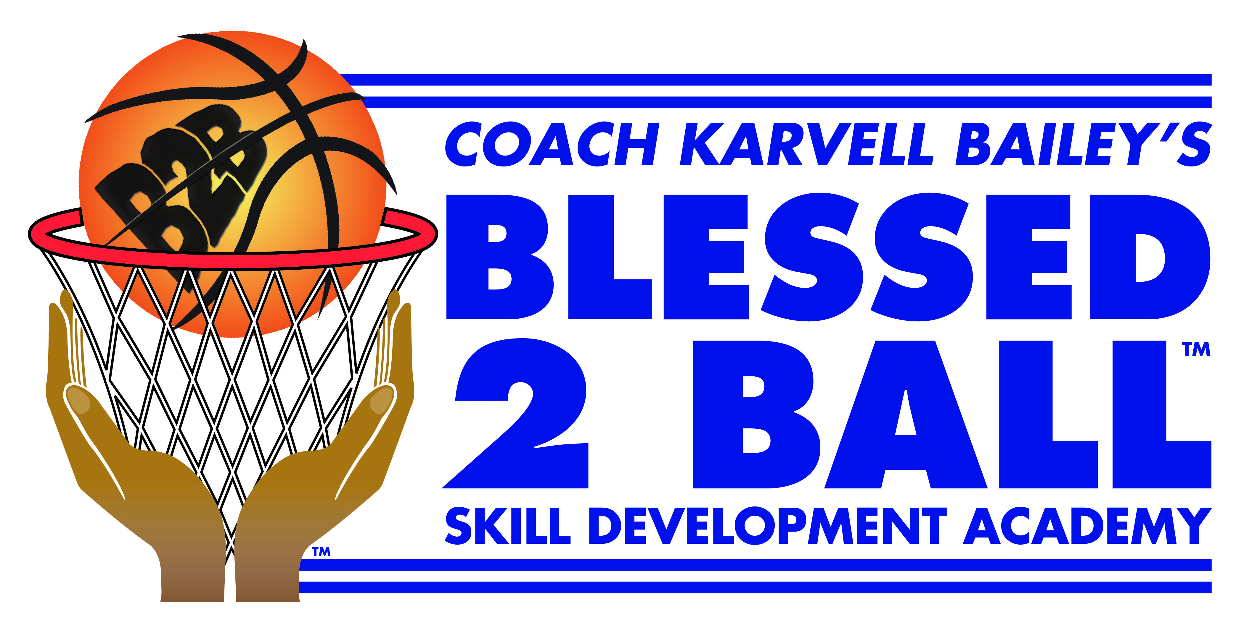
Accident Waiver and Release of Liability

I __________________________ HEREBY ASSUME ALL OF THE RISKS OF PARTICIPATING AND/OR VOLUNTEERING IN THIS ACTIVITY OR EVENT, and waive, release and discharge Alric Karvell Bailey, said personnel, Volunteers, and the activity or event sponsors of the Blessed to Ball Skill Development Academy, From any and all liability, including but not limited to, liability arising from the negligence or fault of the entities or persons release, for my death, disability, personal injury, property damage, property theft, or actions of any kind which may occur to me as a result of participation in the above named activity at the said facility. I agree to indemnify, hold harmless, and promise not to sue the entities or persons mentioned above from any and all liabilities or claims made as a result of participation in this activity or event, whether caused by liabilities or claims made as a result of participation in this activity or event, whether caused by the negligence of those released or otherwise. This accident waiver and release of liability shall be construed broadly to provide a release and waiver to the maximum extent permissible under applicable law. I hereby grant permission to the rights of my image, likeness and sound of my voice as recorded on audio or video tape without payment or any other consideration. I understand that my image may be edited, copied, exhibited, published or distributed and waive the right to inspect or approve the finished product wherein my likeness appears. Additionally, I waive any right to royalties or other compensation arising or related to the use of my image or recording. I also understand that this material may be used in diverse educational settings within an unrestricted geographic area. By signing this release I understand this permission signifies that photographic or video recordings of me may be electronically displayed via the Internet or in the public educational setting. I CERTIFY THAT I HAVE READ THIS DOCUMENT, AND I FULLY UNDERSTAND ITS CONTENT. I AM AWARE THAT THIS IS A RELEASE OF LIABILITY AND A CONTRACT AND I SIGN IT ON MY OWN FREE WILL. ___________________________________________________________________________
Participant Name Grade Participant’s Signature

(If participant is under 18 years old, parent must sign also) PARENT/GUARDIAN WAIVER FOR MINORS (Under 18 years old) The undersigned parent and natural guardian does hereby represent that he/she is, in fact, acting in such capacity, has consented to his/her child or ward’s participation in the activity or event, and has agreed individually and on behalf of the child or ward, to the terms of the accident waiver and release of liability set forth above. The undersigned parent or guardian further agrees to save and hold harmless and indemnify each and all of the parties referred to above from all liability, loss, cost, claim, or damage whatsoever which may be imposed upon those parties because of any defect in or lack of such capacity to so act and release those parties on behalf of the minor and the parents or legal guardian.

_____________________________________________________________________________________
Participant’s Name Age Date

_____________________________________________________________________________________
Signature of Parent or Guardian. Date

_______________________________________________________________________________________
Emergency Contact Relationship

